47th JawaharLaL Nehru NationaL Science, MatheMatics and Environment Exhibition (JNNSMEE – 2020) For children

Theme : SCIENCE AND TECHNOLOGY FOR SUSTAINABLE DEVELOPEMENT

WRITE UP for
DISTRICT LEVEL SCIECNE EXHIBITION
WEST GODAVARI, ANDHRAPRDESH

Venue: Z.P.BOYS HIGH SCHOOL
TANUKU -534211, W.G.Dt., A.P.
Dates: 03-12-19 to 05-12-19
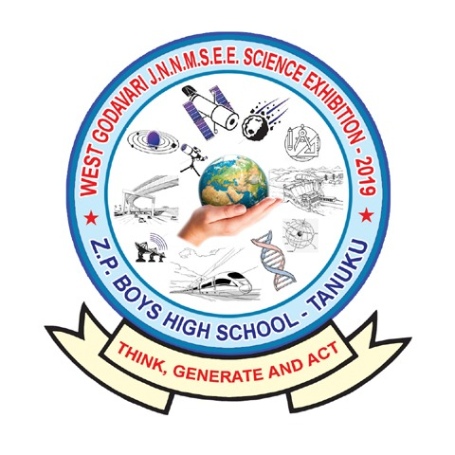
Name of the Student:
Sub-Theme:
Title of the Exhibit:
School Address:

Exhibit Registration No.:__________________ Room Alloted:________

(Submit 3 copies of Bold Letter Computer typed write up on A4 sheet )

47th Jawaharlal Nehru National Science, Mathematics and Environment Exhibition (JNNSMEE – 2020) For children
Theme : SCIENCE AND TECHNOLOGY FOR SUSTAINABLE DEVELOPEMENT
Proforma I
INFROMATION ABOUT THE EXHIBIT/MODEL

1. Title of the Exhibit/model ...............................................................................
(in BLOCK letters)

2. Sub–theme:
- Sustainable Agricultural Practices
- Cleanliness and Health
- Resource Management
- Industrial Development
- Future Transport and Communication
- Educational Games and Mathematical Modeling
- Other (please specify sub-theme); ...................................................................

3. Name(s) of Contributing Student(s) ...............................(M/F); Class.......................
(in BLOCK letters) ................................(M/F); Class........................
................................(M/F); Class........................
................................(M/F); Class........................
Mobile No:………………………. e-mail ID: ………..…………………………………………
- Name(s) of Guiding Teacher(s) 1. (M/F)
(in BLOCK letters) 2. (M/F)
Mobile No:……………………… e-mail ID: ……..……………………………………………….
- Name of school with complete postal address (in BLOCK letters) :
......................................................................................................................................
......................................................................................................................................
...................................................State/UT............................ Pin ...................................
Phone: .......................................; Email ........................................................................

- Type of school* Government/Local Body/ Private Aided/Private
Unaided/ Any other (Please Specify) ..........................
.................................................................................................

- Affiliation of the School State Board/ICSE/CBSE, Any other (Please Specify)
..............................................................................
- Location of the School Tribal/Rural/Backward/Semi Urban/Urban
..................................................................................
- Nature of the Exhibit/Model (A) Innovative/Improvised Apparatus
(B) Working/Static Model/Study Report
Any Other (Please Specify) .........................................
- Whether Dark Room Space is needed for the display of Exhibit: Yes/No

- Approximate space required for the display of Exhibit..............................................

- Source of inspiration/help for preparing the exhibit/model:
(Please explain briefly about the nature and form of help received from the following):
  - From Teachers/School
...........................................................................................................................
...........................................................................................................................
  - From Parents
...........................................................................................................................
  - From Peer Group
...........................................................................................................................
...........................................................................................................................
  - Any other
...........................................................................................................................
...........................................................................................................................
- Brief Summary (Please explain the purpose (or aim) and the scientific principle involved in the exhibit/model in not more than three lines).

.....................................................................................................................
.....................................................................................................................
.....................................................................................................................
............................................................................................................................................................................................................................................
- Write–up of the Exhibit/Model (not more than 1,000 words) in the following format. [Note: Proper submission of the write–up will ensure that if selected for participation in the 47 Jawaharlal Nehru National Science, Mathematics and Environment Exhibition (JNNSMEE–2020) for Children – 2020, it will be considered for publication in the booklet entitled: Structure and Working of Exhibits. For convenience, examples of write–ups of exhibits are also given in this booklet.]

*G. Government: A Government School is that which is run by the State Government or Central Government or Public Sector Undertaking or an Autonomous Organisation completely fi- nanced by the Government;
LB. Local Body: A Local Body School is that which is run by Panchayati Raj and Local Body Insti- tutions such as Zila Parishad, Municipal Corporation, Municipal Committee or Cantonment Board;
PA. Private Aided: A Private Aided School is that which is run by an individual or a private organ- isation and receives grants from the Government or Local Body;
PU. Private Unaided: Private Unaided School is that which is managed by an individual or a private
organisation and does not receive any grant from the Government or Local Body.

- Introduction
  - Purpose (or Rationale) behind the development or construction of the
exhibit; and

  - The scientific principle involved.

- Description
  - Materials used for the construction;

  - Construction and working of the exhibit/model; and

  - Applications, if any.

- References
Books, journals or magazines referred for preparation of the exhibit/ model.

- Illustrations
  - Black and white line and labelled diagram of the model, illustrating the working of the exhibit/model.

  - Close – up photographs of the exhibit/model.

- Five minutes video presentation in CD by the student about the exhibit con- taining (i) title of the exhibit (ii) sub–theme of the exhibit (iii) working of the exhibit (iv) scientific principle involved in it (v) application etc. should also be sent along with the write–up.
Note: (i) Please do not pin or paste the photographs of the exhibits. Enclose them in a
separate envelope. Description of the photograph may be written on its back.
- Please do not enclose the photographs of participating student(s) and their
guide teacher(s)
- Please of not send the scanned/soft copies of write–ups instead of video pre- sentation.
- Submit Bold Letter Computer typed write up on A4 sheet only (3 copies)

CERTIFICATE OF ORIGINALITY

We,................................................................................................................................hereby declare that the submitted exhibit/model is our original creative work / modified form of available work and to the best of our knowledge, this exhibit/model has never been developed by any other person in this form.
(Strike off, whichever is not applicable.)

(Signatures of all students and teachers)

//Counter Signed by Headmaster//

BONAFIED CERTIFICATE
Certified that Mr./Kum. ________________________________________________ S/o.,D/o. ___________________________________________________ , of ___th Class who is participating in 47th Jawaharlal Nehru National Science, Mathematics and Environment Exhibition (JNNSMEE – 2020) For Children at ZP BOYS HIGH SCHOOL, TANUKU, is a Bonafied student of __________________________________________School ______________________________ (Village), __________________________________ Mandal, West Godavari District.
The photograph of the student is attested here under.
Photograph of student attested by headmaster

Signature of the Headmaster

(ONE copy to be submitted on a SEPARATE A4 SHEET for Each student)

